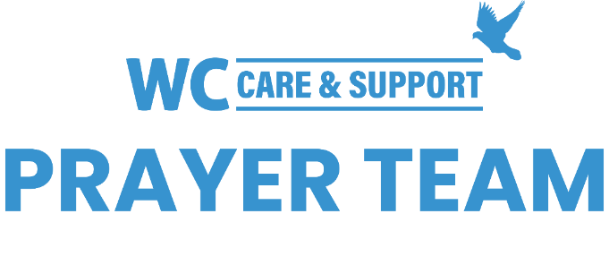

Public Prayer List 03-20-2023

Jack Bair, Carol Barret, Walt Barret, Jerry Barron, Michelle Bartunek and Family, Laura Baumgartner, Mark Baumgartner, Joyce Billingsley, Mindy Bogan, Bonnie Jo Bramhall, Kay Brandt, Marlin Brandt, Cheryl and Ernie Brashear, Ron and Carol Bryant, Ruby Buffalo, Joe Burns, John Cairns, Bobbie Cameron, Nikki Campbell, Connie Center, Hsiao-Lan Chung, Graeme and Meena Clugston, Levi Dietz, Bobbi Dunbar, Duncan Duvall, Wilma Dykman, Ralph Evans, Brian Fenley, Mark Fidler, Charlotte Fox, Roland Galyean, Jane Grazer, Chuck Gregg, Chris Gruenewald, John Guthrie, Janis Haertling, Tiffany Hall, Judith Hallam, Alberta Hays, Barbara Sidorowicz Heide, LoCinda Hennerberg, Jan Hennig, Art Hill, Chelsea Hill, Kathy Hines, Jarrett Hodnett, Charlotte Holland, Dennis Howry, Bill Jacobs, Emma Grace Jeffiers, Claudia Jenkins, Doug Jenkins, Scott Klingensmith, Dolores Kopesec, Joan Kowalski, Connie Lamb, Caleb Graham Larson, Ann Lee, Bernhard Lehder, Rich Lyon, Quisha Matthews, Kosse Maykus, Betty McKay, Kelli Meyers, Leara Miles, Buddy Mincey, Ed Molberg, Bob Morgan, Thomas W. Morris, Ellie Nadeau, John Nadeau, Elida Parish, Rondi Perry, Gerti Phillips, Kathy Pierce, Otto Pollei Jr., Lynne Pompetti, Jerome Reed, Jim and Mary Renner, Kim Rhodes, Allison Rice, Johnnie Ruth Rogillio, Dottie Rushing, Beth Scoggins, Diane Shafer, Ken Sheffield, Betty Shelby, Jeanie Shoop, Alan Smith, Christy Smith, Don Snyder, Sid Soileau, Gayle Sorenson, Doris Splichal , Jasper Talley, Carolyn Thompson, Jenny Thornell, John Ulman, Brenda Walker, Gaylene Wallace, Paula Watson, Terry Webster, Dick Williams, Radell Williams, Ida Wilson, Leigh Winzeler, Dave Zebriski. Recent deaths: The Family of Celinda Allen, Walt Anthony and Family, The Family of Helen Bartkowiak, The Family of John Booth, Jim and Becky Carmichael and Family, The Family of Diann Clary, The Family of Wade Elliott, The Family of Eric Falls, The Family of Marilyn Hale, The Family of Rita Lerae Hight, The Family of Ron Johnson, The Family of Michelle Long, The Family of Barbara Peacock, The Family of Paul Quiroga, The Family of Pamela Rhoads, The Family of Janet Richter, The Family of Caleb Stewart, The Family of Larry Vowell, The Family of Lauren Elise Williams.

You may submit prayer requests at https://www.whiteschapel.org/prayers.html.

