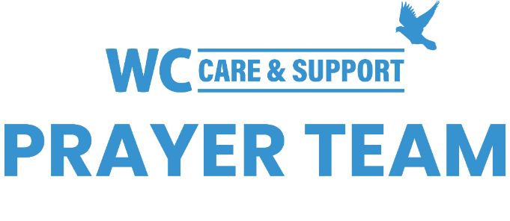
You may submit prayer requests at the following link or use this QR code: www.whiteschapel.org/prayers.html. Names will remain on this prayer list for two weeks, three weeks for deaths, unless otherwise notified. | 

Public Prayer List 03-23-2026

Nasim Akar, Malta Akins, Rae Albertini, Roland Anderson, Jack Beam, Brent Bedgood, Jim Blair, Nancy Bradley, Mrs. Bunker, Bobbie Cameron, Kay Chapman-Coy, Lola Cobb, Carolyn Cockerell, Bill and Jimmie Nell Cook, Leslie Craig, Logan Davis, Karen Dickey, Paige Dobyns, Lisa Elam, Sue Ensslen and Family, Anna Ericson, Ralph Evans, Kyle Fairchild, Jennifer Fordham, David and Connie Fred, Kelly and Austin, Emmy Gaarder, Morris Gates, Dexter Gatlin, Shelly Gillette, Kay Hasseltine, Maxie Hays, Sally Henneberger, David Hinkle, Keira Hodges, Joy Holekamp, Alice Knowles-Holliday, Robert Holmes, Mary Howry, Bill Hudson, Michelle James, Tom Jenkins, Barry Johnson, Jerry Kight, Dolores Kopesec, Connie Lamb, Jon Lamb, Zephyr Lee, Robin Long, Marshall Ludwig, Reba Madera, Sharon Martin, Carl Matthys, Katherine McCarthy, Debbie McCullough, Sue McNutt, Rev. Sam McRae, John Melton, Matthew Mitchell, The Montecillo Family, Jamie Monticello, Dave Mueller, Ross Mulholland, Aaron Neuding, Kayla and James Oliver, Christopher Owen, Dee Perkins, Azor Phelps Sr., Kay Pierce, Bill Preston, Norma Resendiz, Kathryn Robbins, Eddie Robertson, Adriana Rodriguez, Heath Roy, Jim Rupe, Pat Server, Barbara Shaw, Paul Sikes, LeGrand Spradley, Dean Stacy, Bill Stevenson , Steve Swanston, Oscar Temblador, Judy Tong-Allcock, U.S. Military, Jacob Utley, Rick Warner, Timothy Weaver, Shannon Weimers, Ellie Whiddon, Megan and Eric Whitehead, Luke Williamson, Carroll Willis, Warren Willis, Linda Winant, Vicki Winn, Melinda Witt, Kay Young, Rocio Zarubiak, Emma, Lawrence, Tatum. Recent deaths: The Family of Enrique Aliva Jr., Morgan Callaway and Family, The Family of Judy Greenwald, The Hinkle Family , Tom Mann and Family, The Family of Doyle McAda, The Family of Nancy Melton, The Family of Brian Nance, The Family of Jimmie Slough, The Family of Rick Varner.

