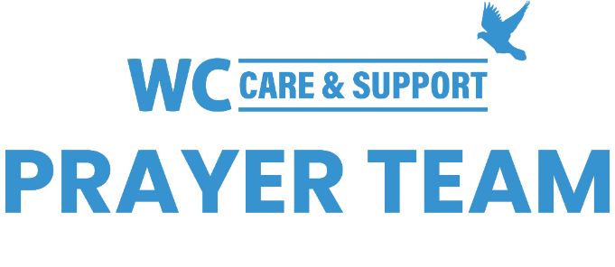
You may submit prayer requests at the following link or use this QR code: www.whiteschapel.org/prayers.html. Names will remain on this prayer list for two weeks, three weeks for deaths, unless otherwise notified. | 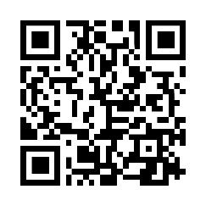

Public Prayer List 12-08-2025

Catherine and Austin Ackerman, Roland Anderson, Carol Barret, Al Bender, Jim Bills, Jason Bolanz, Jim Bottrell, Nancy Bradley, Cheryl Brashear, Sarah Brown, Bobbie Cameron, Pat Carpenter, Kay Chapman-Coy, Tommy Clark, Lola Cobb, Carolyn Cockerell, Bill and Jimmie Nell Cook, Ken Cornell, Nevin Cunningham, Barton Davis, Travis Deering, Amy DeGray, Carol Dominiec, Jim Dougherty, John and Amy Duckworth, Ralph Evans, Terry Fisher, Mary Franco, George Friend, Brandi Yellock Frugé, Emmy Gaarder, Shelly Gillette, Brenda Glimstad, Betsy Godbold, Buddy Hall, Harper Hayes Hall, Tiffany Hall, Lynne Hein, Larry Hoover, Paulo Jacuzzi, Michelle James, Gerald Kemp, Christopher Kender, Jerry Kight, Dean Kim, Stace Kissinger, Debbie Kissire, LaJuana Knott, Catherine LaCroix, Connie Lamb, Ashley Barret Leder, Judy Lemons, Jackson Little, Alfonso Lizarralde, Susie Malone, Sharon Martin, Tex McCarthy, Shari & Ron McFarland, Philip McMahan, Sue McNutt, Matthew Mitchell, Jeff Moody, Pam Moore, Kathy Morse, Dave Mueller, Jim Murray, Myra Nunez, Alexis Okura, Joy Reece, Jon Reeves, Norma Resendiz, Gale Rivers, Jane Robertson, Lonna Rogers, Daniel Shafer, Nancy Shull, Paul Sikes, LeGrand Spradley, Michael Sprufera, Charles and Janice Stahl, Steve Swanston, Paul Tacker, Leeann Tice, Carter Timms, John Underwood, Angie Vaughan, Linda Wallace, Rick Warner, Joe Watford, Carley West, Vicki Winn, Marj Witherspoon, Mark Wolfe. Recent deaths: The Family of Jerry Barron, The Family of Bonnie Bloxham, The Family of John and Michael Daly, The Family of Bill Ellermeyer, The Family of Bob Fisher, The Family of Erin Griswold, The Family of Emma Hackney, The Family of Bob Horn, The Family of Lisa Louks, The Family of Betty Shaw, The Family of Julie Timmons.

