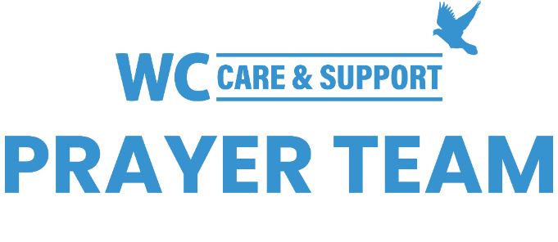
You may submit prayer requests at the following link or use this QR code: www.whiteschapel.org/prayers.html. Names will remain on this prayer list for two weeks, three weeks for deaths, unless otherwise notified. | 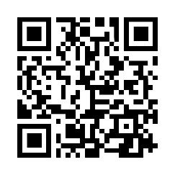

Public Prayer List 01-12-2026

Malta Akins, Brayden, Gaye and Sandy Anderson, Roland Anderson, Meryl Babcock, Carol Barret, Nathan Barrett, Brent Bedgood, Nancy Bradley, Bonnie Jo Bramhall, Bobbie Cameron, Andrew Campbell, Lola Cobb, Ruth Cochran, Carolyn Cockerell, Bill and Jimmie Nell Cook, Gary Cooper, Terri Craddock, Susanna Cunningham, Sam D., Elizabeth Davis, Barbie Derby, Carol Dominiec, Jim Dougherty, Jan Emory, Anna Ericson, Ralph Evans, Terry Fisher, Frank Forcelli, Jennette Forrester, Brandi Yellock Frugé, Don Gardner, Roger Gerlach, Paul Gidlund , Shelly Gillette, Betsy Godbold, Alice Hall, Buddy Hall, Tiffany Hall, Vernon Lee Harrity, Jim and Donna Houston, Michelle James, Joanne Johnson, Helen Kimble Kutch, Jennifer Kohan, Connie Lamb, Ashley Barret Leder, Mona Lewis, Jackson Little, Sharon Martin, Tycie Max, Tex McCarthy, Sue McNutt, Jeff Miller, Dave Mueller, Charmayne Myers, Olivia Mysliwiec, Kayla and James Oliver, John Phillips, Bobby Phipps, Helen Post, Norma Resendiz, Gale Rivers, Eddie Robertson, Jane Robertson, Johnnie Ruth Rogillio, Ashton Rone, The Schulers, Paul Sikes, Patsy Smith, LeGrand Spradley, Julie Stapleton, Steve Swanston, Cyndi Tait, Roger Trevino, Barry Wahrmund, Rick Warner, Joe Watford, Martha Weaver, Tom Webber, Carley West, Liz West, Lynn Will, Luke Williamson, Vicki Winn, Melinda Witt, Mark Wolfe, Will Zamudio. Recent deaths: The Family of Bobbie Barnes, The Family of Cheryl Brashear, The Family of Jill Burr, The Family of Harriet Colvin, The Family of Ron Fant, The Family of Renee Nicole Good, The Family of Patrick Green, The Family of Carmello Mega, The Family of Thomas Q. Robbins, The Family of Ken Thomason, The Family of Frederick Timmerman, The Family of Linda Wallace.

