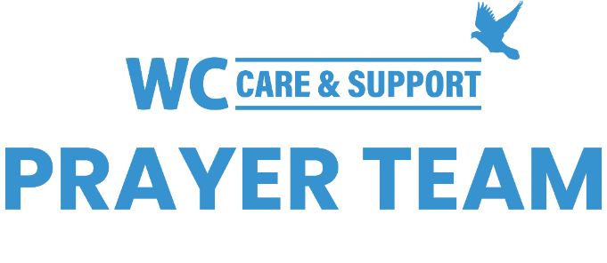
You may submit prayer requests at the following link or use this QR code: www.whiteschapel.org/prayers.html. Names will remain on this prayer list for two weeks, three weeks for deaths, unless otherwise notified. | 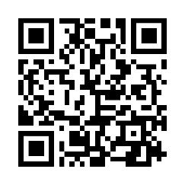
Public Prayer List 10-20-2025

Charlie Anderson, Mindy Aunkst, Andrew Balson, Chuck Banta, Chris Bechill, Carolyn Betty, Judy Blalock, Stacy Bockholt, Mike Bradley, Cade Bradshaw, Cheryl Brashear, Stephen Brischke, Lauren Callahan, Bobbie Cameron, Jill Carter, Jackie Black Chaffins, Lola Cobb, Carolyn Cockerell, Leslie Craig, Amy DeGray, Tom and Nancy Delaney, Steve Dowd, John and Amy Duckworth, Bill Ellermeyer, Ralph Evans, Laurie Evans, Dorothy Fontana, Gerrye Frantz, Brandi Yellock Frugé , Emmy Gaarder, David Gaona, Marcelle Ghattas, Shelly Gillette, Betsy Godbold, Tiffany Hall, Maxie Hays, Raymond Hebert, Karen Hodges, Bob Horn, Mary Howry, Bob Hughey, Michelle James, Logan Jeffiers, Jerry Kight, LaJuana Knott, Cooper Kohan, Phil Kubiak, Debi Lamarr, Connie Lamb, Julie Langston, Michael Lee, Grace London, Luke Lunday, Jeff and Liz Marshall, Sharon Martin, Chance McCarthy, Sue McNutt, Baby A Moses, Jenny Murphy, Lucia Orosco, Bill Preston, Jon Reeves, Ethan Robinson, Scott Sabre, Kim Schlitter, Nancy Shull, Kathy Skinner, Keri Galyean Snider, Nancy Steffel, Jamieson Stewart, Orville Summey, Steve Swanston, R.J. Thomas II, Rebecca Shivers Utley, Linda Wallace, Rick Warner, Kelly Weaver, Carley West, Ken Williams, Carroll Willis, Linda Winant, Vicki Winn, Leigh Winzeler, Jana Woodruff, Kasey Young, Gladys Zrake. Recent Deaths: Misty Anderson and Family, The Family of Roger Claybaugh, The Family of Amanda Deitz, The Family of Bill Dreger, The Family of America Ellis, The Family of Connie Hessing, The Family of Zak Marr, The Family of Louise McKenzie, The Family of Wayne Meckley, The Family of Mel Schlueter, The Family of Colleen Stewart, The Family of Tony Tommasi.

