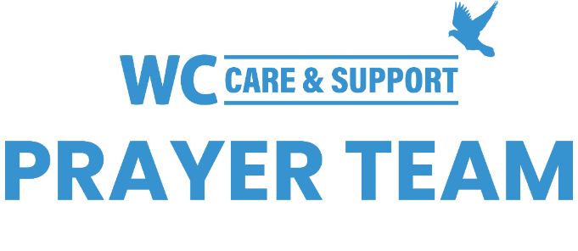
You may submit prayer requests at the following link or use this QR code: www.whiteschapel.org/prayers.html. Names will remain on this prayer list for two weeks, three weeks for deaths, unless otherwise notified. | 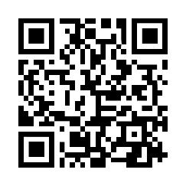
Public Prayer List 04-04-2026

Dave Aistrup, Malta Akins, Rae Albertini, Cristina Almeida, Roland Anderson, Artemis II Astronauts, Chase Attwood, Jack Beam, Brent Bedgood, Julie Bessire, Ruth Blaser, Nancy Bradley, Ray Burget, Bobbie Cameron, Jill Carter, Jackie Black Chaffins, Kay Chapman-Coy, Lola Cobb, Carolyn Cockerell, Janice Colvin, Bill and Jimmie Nell Cook, Clay Cook, Kelly Cook, Karsen Crow, Paul Cuttica, Rachel Dahl, Logan Davis, Karen Dickey, Tommy Duer, Kimberly Eltiste, Kerry Emmert, Ralph Evans, Reed Evans, Jennifer Fordham, David and Connie Fred, Kelly and Austin, Emmy Gaarder, Morris Gates, Dexter Gatlin, Shelly Gillette, Jim Hall, Kay Hasseltine, Christy Hillmer, Joy Holekamp, Robert Holmes, Bill Hudson, Michelle James, Tom Jenkins, Lynn Joseph, Jerry Kight, Dolores Kopesec, Amy DeGray and Family, Connie Lamb, Debra Langdon, Annette Willmon Lee, Perry Lindsay, Robin Long, Marshall Ludwig, The Major Family, Sharon Martin, Sue McNutt, Denise Missimo, Matthew Mitchell, Sherry Modeer, Jamie Monticello, Kayla and James Oliver, Christopher Owen, Dee Perkins, Azor Phelps Sr., Kay Pierce, David Pote, Bill Preston, Robert Radtke, Norma Resendiz, Eddie Robertson, The Ruby Family, Butch Sanders, Barbara Shaw, Hannah Shroyer, Roland Sierra, Paul Sikes, LeGrand Spradley, Bill Stevenson, Steve Swanston, Elmer T., Chris Tong, Judy Tong-Allcock, U.S. Military, Paul Wang, Rick Warner, Joe Watford, Timothy Weaver, John Wermuth, Kimberly West, Ellie Whiddon, Wes Whiddon, Leslie Williams, Luke Williamson, Carroll Willis, Vicki Winn, Melinda Witt, Janie Woodward, Trina Zagar, Daniel and Jackson, Emma, Lawrence, Tatum. Recent Deaths: The Family of Enrique Aliva Jr., The Apel Family, The Family of Jim Blair, The Family of Jeanna Brady, The Family of Raymond Hebert, Tom Mann and Family, The Family of Doyle McAda, The Family of Nancy Melton, The Family of Brian Nance, The Barbara and Alex Rocha Family, The Family of Shirley Runyon, The Family of Dolores S., The Family of Jean Elias Samaan, The Family of Jimmie Slough, The Family of Kyley Weaver.

