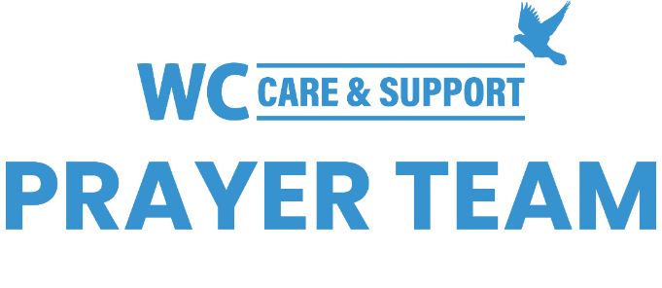
You may submit prayer requests at the following link or use this QR code: www.whiteschapel.org/prayers.html. Names will remain on this prayer list for two weeks, three weeks for deaths, unless otherwise notified. | 

Public Prayer List 11-03-2025

Patti Ackley, Charlie Anderson, Andrew Balson, Chuck Banta, Carol Barret, Jerry Barron, David Baxley, Carolyn Betty, Mike Bradley, Cade Bradshaw, Cheryl Brashear, Sarah Brown, Zach Bruton, David Buddin, Mark Burdette, Lillian Cabla, Bobbie Cameron, Pat Carpenter, Jesse Cobb, Lola Cobb, Ruth Cochran, Carolyn Cockerell, Cliff Courtney, Nevin Cunningham, Barton Davis, Rick Davis, Amy DeGray, Tom and Nancy Delaney, John and Amy Duckworth, Bill Ellermeyer, Laurie Evans, Ralph Evans, Dorothy Fontana, Brandi Yellock Frugé, Emmy Gaarder, Landon Gaspari, Janice Gauntt, Marcelle Ghattas, Shelly Gillette, Betsy Godbold, Tiffany Hall, Maxie Hays, Raymond Hebert, Al Hermansen, Karen Hodges, Mary Howry, Evelyn Iszak, Logan Jeffiers, Annette Keller, Lynda Knorpp, LaJuana Knott, Cooper Kohan, Debi Lamarr, Connie Lamb, Michael Lee, Robert Lott, Lisa Louks, Michael Lucas, Luke Lunday, Steven Mart, Sharon Martin, Chance McCarthy, April McCartney, Sue McNutt, Barb Mundis, Jenny Murphy, Kayla and James Oliver, Beth Paschall, Ray Payne, Lee Penney, Azul Picazo, Tom Powers, Bill Preston, Jon Reeves, Norma Resendiz, Jane Robertson, Ethan Robinson, Jim Rupe, Scott Sabre, Jim Sanders, Kim Schlitter, Sandy and Deetz Shepherd, Kathy Skinner, John Sloan, Clint Smith, Mike Smith, Patsy Smith, Keri Galyean Snider, Kris Sorowasz, Marshall Sorowasz, LeGrand Spradley, April Stafford, Nancy Steffel, Jamieson Stewart, Orville Summey, Steve Swanston, Paul Termin, Keller Trent, Linda Wallace, Rick Warner, Carley West, Jackson Widaman, Ken Williams, Linda Winant, Vicki Winn, Leigh Winzeler, Jana Woodruff. Recent deaths: Misty Anderson and Family, The Family of Judy Faulkner Bostick, The Family of Roger Claybaugh, The Family of Steve Dowd, The Family of Gerrye Frantz, The Family of Wayne Meckley, The Family of Cile Steward, The Family of Myra Taunton, The Family of Glen Wahrmund, The Family of Gladys Zrake.

